**Agspring Standard SSIS ETL Development Package**

To ease development Agspring has a standard template so developers can focus on business logic and not worry about the details of logging. Additionally, the standard package allows ease of promotion from development to production without significant changes to the package itself.

**Working with the sample package**

Package Properties

When you start a new project follow these steps:

1. Create a new solution and add the existing template AgspringETLTemplate.dtsx
2. In package properties click ID and select generate new ID.
3. Change the CreationDate to today’s date.
4. Change the CreatorComputerName to your computer.
5. Change the CreatorName to your name.
6. Fill in the VersionComments, VersionMajor, and VersionMinor.

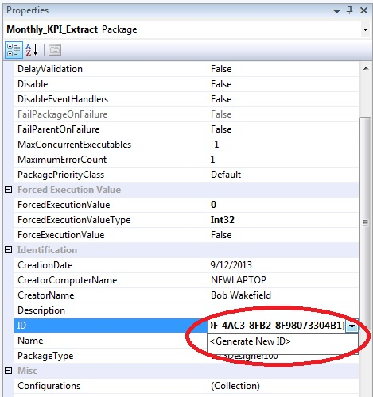

Figure 1. Change package ID.

Package Variables

If you have a variable that you want to track, set that variable’s raise change event property to true.

It is important that you do NOT delete any of the existing variables with the exception of intVariable2 and strVariable1. Those variables are place holders for package configurations. If you have configurations, you can replace them. If you do not, they need to stay or in the alternative, you can delete the Import Configurations task which is not advised.

Task

You can delete the SEQ Package Logic sequence container BUT your control flow MUST begin and end with SQL LogPackageStart and SQL LogPackageEnd respectively.

**Querying The Logging Tables**

There are four stored procedures that you can use to trouble shoot your ETL solution.

|  |  |  |  |
| --- | --- | --- | --- |
| **Procedure Name** | **Parameter** | **Parameter Data Type** | **Description** |
| PackageRunTime | @PackageName | VARCHAR(MAX) | Pass in the name of the package. Tells you how long an individual package ran. |
| ErrorLogByBatch | @BatchID | INT | Pass in the batch ID. Tells you all the errors in a particular batch. |
| BatchRunTime | @BatchID | INT | Pass in the batch ID. Tells you how long a particular batch ran. |
| ErrorLogByPackage | @PackageName | VARCHAR(MAX) | Pass in the name of the package. Tells you errors for a particular package. |

Developers are encouraged to write their own procedures for their own troubleshooting needs. The ERD for the logging tables is attached below.



Creating new configuration settings

Developers are encouraged to make packages as flexible as possible by using package configurations. Package configuration creation is explained in the attached sample script.

